**Phase 1: Problem Understanding & Industry Analysis**

**Requirement Gathering**

Educational institutions, especially colleges and universities, face challenges in handling thousands of student inquiries during admission seasons. Currently, most follow a **manual or semi-digital approach** (Excel sheets, emails, phone calls). This causes:

* Loss of potential student leads due to poor tracking.
* Delays in responding to students and parents.
* Difficulty in maintaining a **single source of truth** for student data.
* No real-time visibility of admission progress for management.

Thus, the requirement is to build a **centralized CRM system** that automates lead tracking, improves student communication, and provides real-time dashboards.

**Stakeholder Analysis**

* **Admission Officers** → Manage student inquiries, follow-ups, and applications.
* **Students & Parents** → Expect timely updates, clear communication, and transparency in admission progress.
* **Administrators/Management** → Need dashboards and reports to track admission performance and forecast future trends.
* **IT/Support Staff** → Ensure system availability, user training, and data management.

**Business Process Mapping**

**Current Admission Process (Manual):**

1. Student inquiry received via phone/email/form.
2. Admission officer manually records data in Excel or registers.
3. Follow-up reminders are handled manually.
4. No clear tracking of how many inquiries convert to admissions.

**Proposed Salesforce-based Admission Process:**

1. Inquiries automatically captured as **Leads** in Salesforce.
2. Leads qualified and converted into **Opportunities (Admission Applications)**.
3. Once confirmed, students stored in a **custom object (Student Record)**.
4. Automated email/SMS reminders keep students/parents informed.
5. Dashboards & reports give real-time insights into admissions.

**Industry-Specific Use Case Analysis (Education Sector)**

* **Problem:** High volume of inquiries, lack of follow-ups, poor data visibility.
* **Use Case:** CRM can help institutions manage the full **student lifecycle** from inquiry to admission.
* **Impact:**
  + Increased student conversion rates.
  + Improved communication with students/parents.
  + Enhanced reputation of the institution with a transparent admission process.

**AppExchange Exploration**

Salesforce **AppExchange** already offers education-specific solutions like:

* **Salesforce.org Education Cloud** (for higher education institutions).
* **TargetX CRM** (student recruitment and engagement).
* **Enrollment Rx** (end-to-end admission management).

Our EduCRM project will take inspiration from these real-world solutions but will be a **simplified custom CRM**, tailored for admission tracking and student communication.

**Phase 2: Org Setup & Configuration**

**Overview**

Phase 2 focuses on setting up the Salesforce Developer Org to configure the organization according to project requirements. This includes creating users, profiles, roles, and establishing org settings to ensure proper access and functionality for the EduCRM system.

**1. Salesforce Editions**

* **Developer Edition** was used for this project.
* Provides access to core Salesforce CRM functionalities, suitable for testing and development purposes.

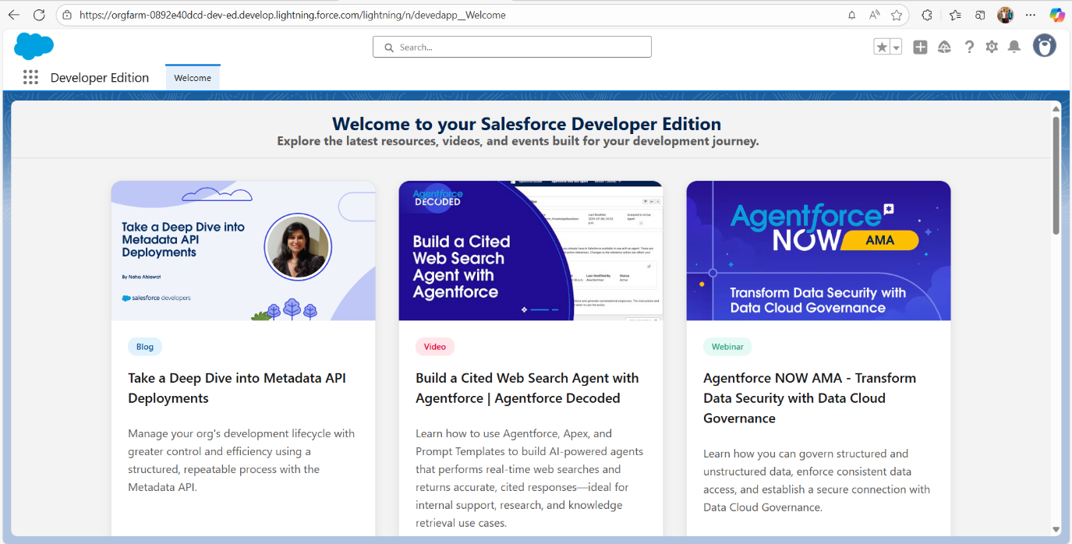

**2. Company Profile Setup**

* Default company settings were used in the Developer Org.
* Company information such as address, default currency, and locale settings were configured according to standard defaults.

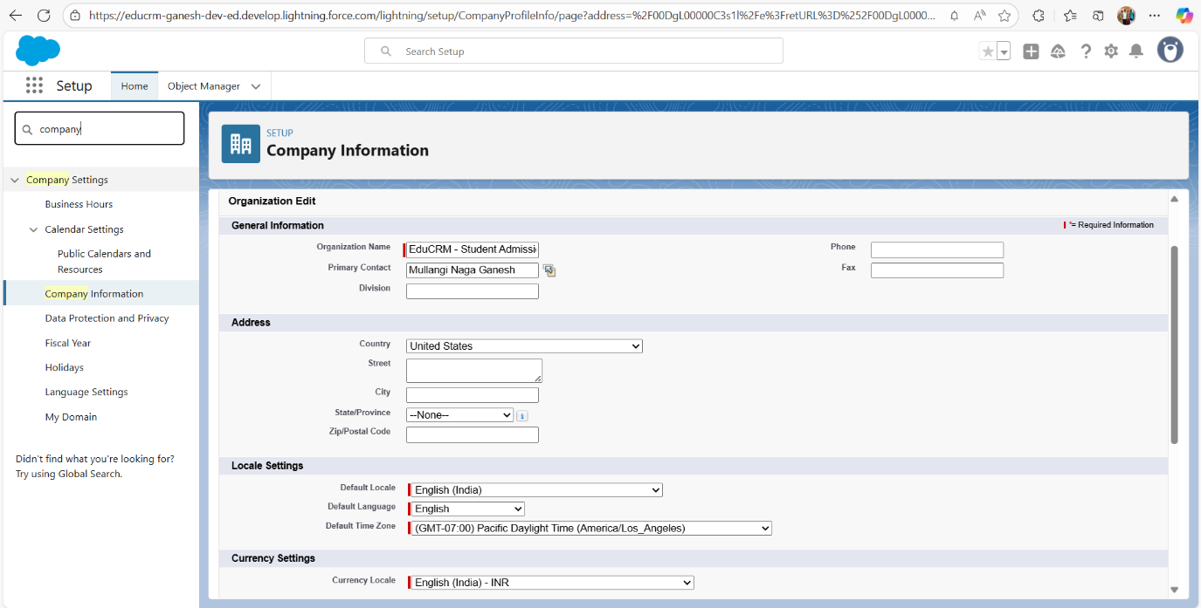

**3. Business Hours & Holidays**

* Default business hours and holidays were used.
* Not critical for the project since automated processes do not depend on business hours at this stage.

**4. Fiscal Year Settings**

* Standard fiscal year settings applied.
* Optional for small-scale projects; no financial reporting automation required at this stage.

**5. User Setup & Licenses**

* **Users Created for EduCRM:**
* Users represent key roles in the EduCRM system for managing admissions and student support.

|  |  |  |  |
| --- | --- | --- | --- |
| Name | Username | Profile | License |
| Admin | System_admin_sadmi@gmail.com | Admin Profile | Salesforce |
| Admission Officer | Admission_officer_admis@gmail.com | Admission Officer Profile | Salesforce Platform |
| Student Support | Student_support_studs@gmail.com | Student Support Profile | Salesforce Platform |

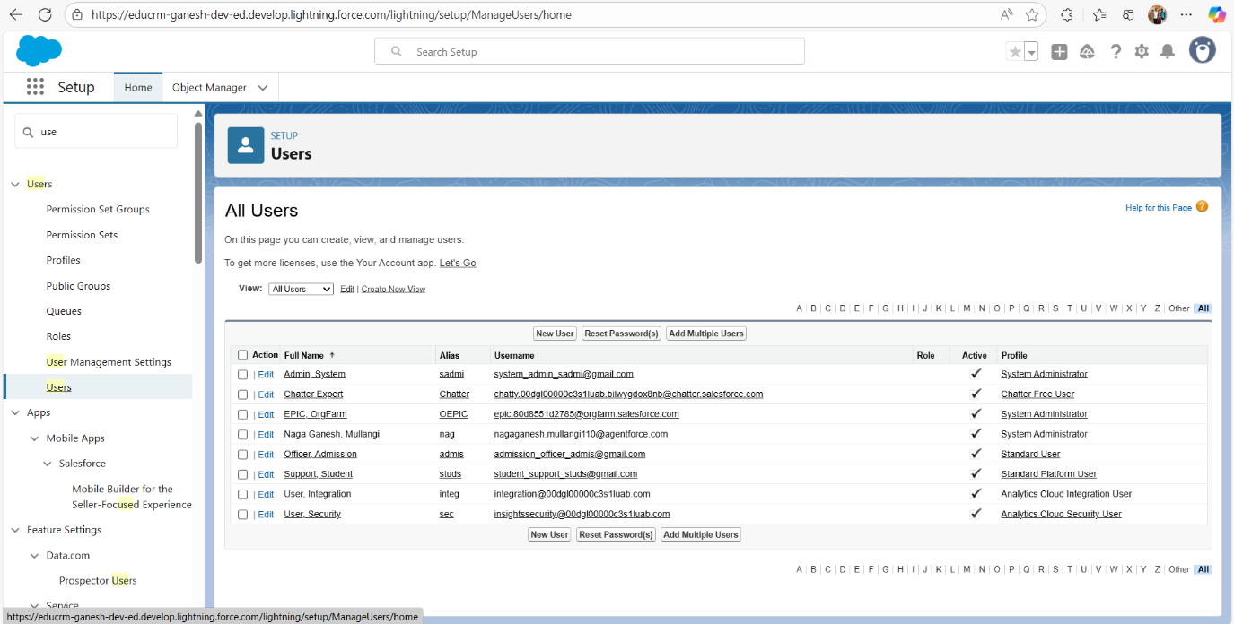

**6. Profiles**

* **Profiles Created / Cloned:**
  1. **Admin Profile** → Full access to all objects and fields.
  2. **Admission Officer Profile** → Access to Student and Admission Application objects.
  3. **Student Support Profile** → Access to Student and Support Ticket objects.
* **Field-Level Security (FLS):** Profiles configured to ensure appropriate visibility and edit permissions.

**7. Roles**

* Role hierarchy ensures proper record access: Admin sees all records, Admission Officers and Student Support see only relevant data.

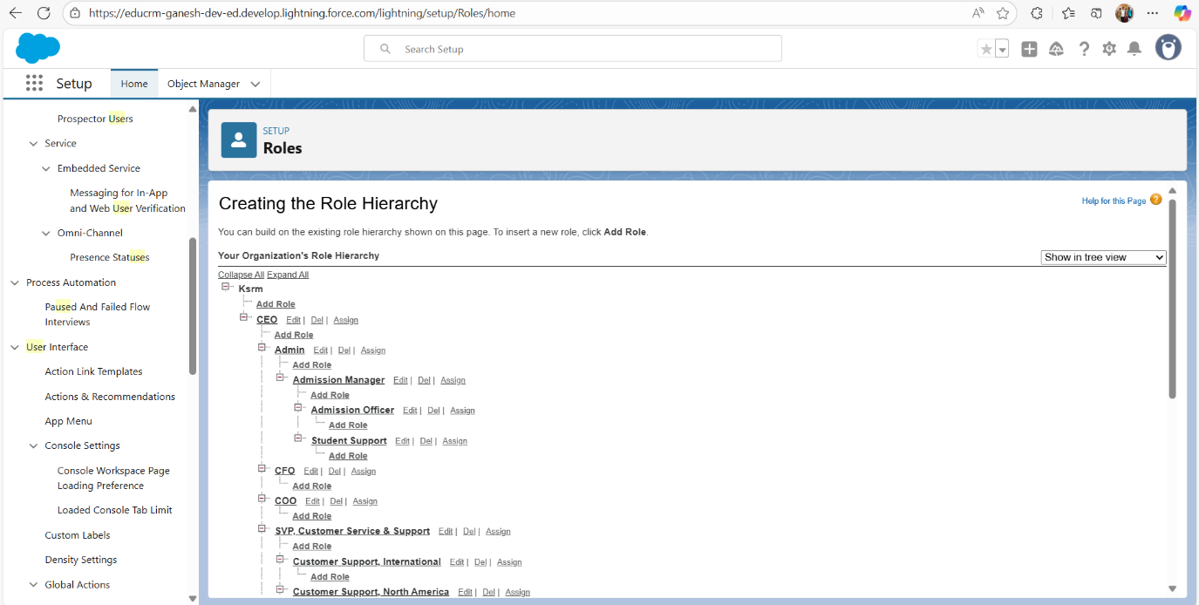

**8. Permission Sets**

* Not created for this project as all access is managed via Profiles.
* Optional for more advanced access control in larger projects.

**9. OWD (Organization-Wide Defaults) & Sharing Rules**

* Default OWD settings used.
* No sharing rules configured since access control is handled via Roles and Profiles.

**10. Login Access Policies**

* Default login access policies applied.
* Ensures secure login for all users.

**11. Dev Org Setup**

* Developer Org is configured and ready for customizations.
* Sandbox not required for this project.

**12. Sandbox Usage**

* Not applicable in Developer Org for this project.

**13. Deployment Basics**

* Deployment not required at this stage; changes are directly made in Developer Org.